BIG changes coming to YOUR neighborhood
The Berkeley City Council is considering a massive change to the zoning ordinance that would allow 3 story, 35-foot-tall buildings with 5+ units and over 8,500 square feet of building on most residential lots in Berkeley. These buildings would not be required to have any parking or design review. Developers can also add accessory dwelling units (ADUs), equal to the number of units in the main building, on any leftover open space. This means that it is possible that the lot next door to you could have 10 or more units of housing and the city would have no ability to stop the project.
There has been almost NO community outreach and NO professional planning to support this indiscriminate rezoning. The rezoning could result in gentrification, property speculation and, perversely, an increase in the cost of land. Additionally, despite the goal of adding thousands of housing units, there are no plans to increase open space or parks, address water shortages, increase the number of EMTs and firefighters, or protect historic homes or existing solar installations.
Berkeley is already providing increased housing on our main corridors, in the UC Berkeley southside neighborhood, and in our downtown. The city far exceeded our regional market rate housing goals in the last two cycles but fell short of providing low income housing. This Middle Housing Ordinance does nothing to guarantee that more low income housing will be built.
Existing zoning and constantly evolving state law already allows the creation of “Missing Middle Housing” on almost any residential lot in Berkeley. Two units PLUS two ADUs are allowed by right already. In some neighborhoods, current zoning ALREADY allows for three houses and three ADUs. This will help increase housing supply, especially for smaller footprint home-ownership opportunities that are truly needed. We think that this provides plenty of opportunities for thoughtful property owners to build smaller homes and condos that may be more affordable than single family homes.
Indeed, you can already see this happening on larger lots in west Berkeley and central Berkeley where older houses are being torn down and replaced by two-to-four-unit homes. When done thoughtfully, these make our neighborhoods better.

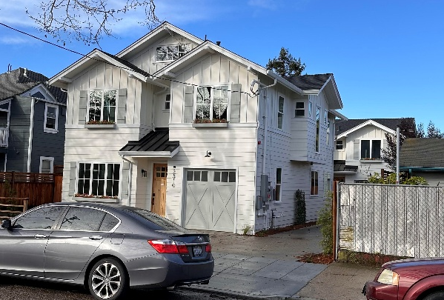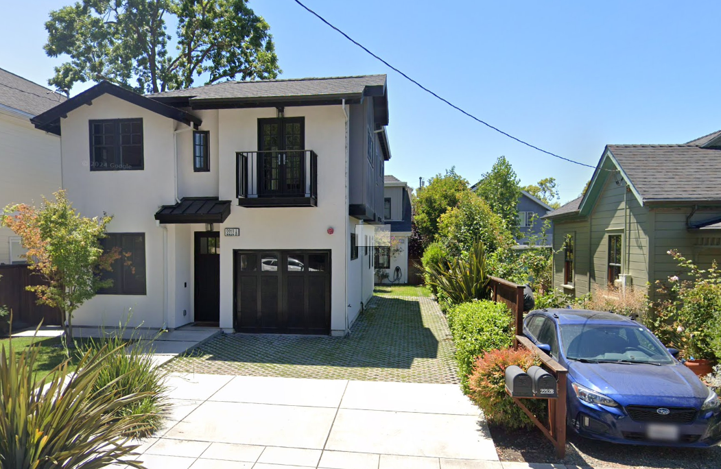
Projects Showing Two houses on One Lot in West Berkeley

Unfortunately, the zoning as proposed will NOT encourage more of these thoughtful infill projects. Instead, it will encourage developers to build three and four-story, apartment buildings that cover the entire lot. This type of zoning in residential neighborhoods was already rejected once because they resulted in real life examples such as these which can be seen throughout Berkeley:
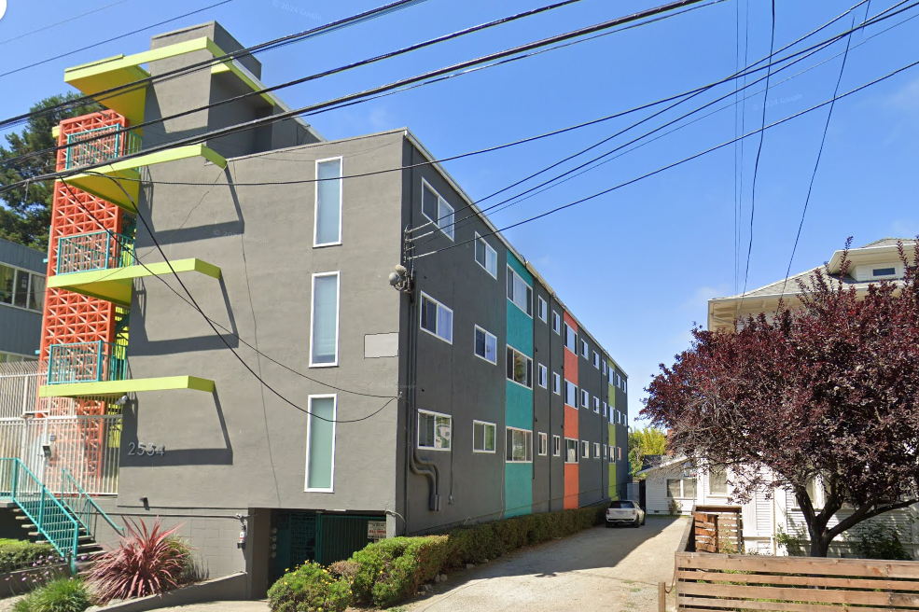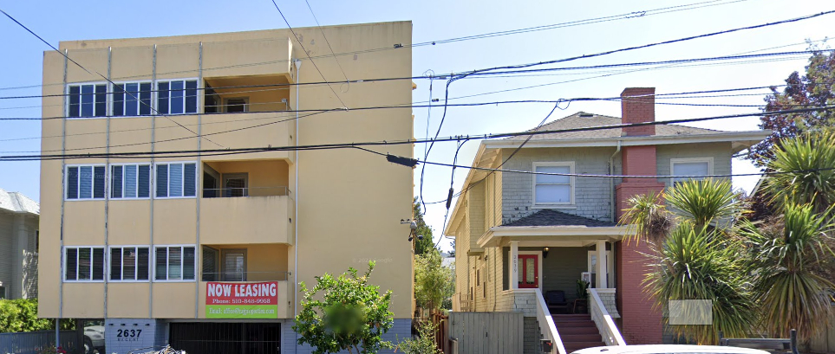
Examples of 3 and 4 Story Apartment Buildings That the New Zoning Would Allow
There are many ways the council can encourage the development of thoughtful housing that is more affordable to families WITHOUT changing current zoning. This process is already underway and can be augmented by waiving certain city fees and costs and simplifying the permitting process.
The current proposal that will soon be before the council lacks thoughtfulness, care, or consideration of potential impacts to our neighborhoods. More Housing Everywhere is a great slogan, but a terrible planning process. If you agree, the city council needs to hear from you BEFORE this rezoning comes back on their agenda. Contact your councilmember and let them know that, while you support more housing built in a way that improves our neighborhoods, you are opposed to a poorly conceived blanket re-zoning of the entire city. Ask your councilmember to support a real planning process that will actually encourage appropriate scaled housing that is affordable to teachers, young families and empty-nesters.
Please take the time to write a unique and personal email and send it to your councilmember and to council@berkeleyca.gov
Mayor mayor@berkeleyca.gov
District 1 rkesarwani@berkeleyca.gov
District 2 ttaplin@berkeleyca.gov
District 3 bbartlett@berkeleyca.gov
District 4 itregub@berkeleyca.gov
District 5 sokeefe@berkeleyca.gov
District 6 bblackaby@berkeleyca.gov
District 7 clunaparra@berkeleyca.gov
District 8 mhumbert@berkeleyca.gov

