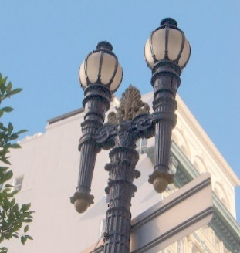
Berkeley Neighborhoods Council

Website: https://berkeleyneighborhoodscouncil.com/
Email: bnc50@berkeleyneighborhoodscouncil.com

Shining the light on Berkeley’s Neighborhoods since 2013.
"BNC is dedicated to improving the quality of life for all by
creating a unified neighborhood voice for promoting livability.”

Join Us

Issue 28: BNC E-News, January/February 2020
During our last general BNC meeting on January 11th, we briefly considered our work in partnering with 18 neighborhood groups and organizations and what that meant in terms of meetings, letters, e-mails and phone calls to elected officials and City Staff to urge them to be more responsive to residents. That inevitably led to thoughts about what went wrong and what went right in the past year. All-in-all, it’s a guess that while most of us are pretty glad that 2019 is over, we’re concerned that the problems we dealt with then have not been resolved by a long shot.

BNC’s 2020 goals are admittedly broad - facilitating social and economic diversity, achieving an environmentally-friendly future, honoring our past, appreciating beauty in urban design, and providing a pathway toward livable, safe, and healthy neighborhoods in all areas of our City. Together, we can get there from here, but our combined efforts are needed more than ever before.

No one should decline participating when you hear of some proposal that concerns you because you’re just too tired from that daily commute, or you don’t want to be called names or shouted at in a meeting, or you think the issue is too big and complex. Your voice IS important – that’s what democracy is all about and always remember, Berkeley is as much your City as it is
someone else’s. Being united in an informed and civil manner in the presentation of views is the best response to name-calling and shouting that there is or ever will be. Further, we have seen that what happens in any part of Berkeley could set a precedent for future actions. Berkeley is too small and compact a City for us not to pay attention to the overall picture. What happens in your neighborhood concerns us all if we really and truly want a livable city for all of us and our children.

With this in mind, here’s a short list of a just a few major FLASH POINTS that will challenge all of us in the year that stands before us. As we looked at this list, we came to the conclusion that our City may well be at a crossroads that will result in forever losing the diverse, innovative, beautiful community we so loved and believed in. Let’s not let that happen!

Our Downtown: 2211 Harold Way
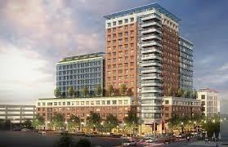
In 2009: 1). Berkeley voters approved a Downtown plan that allowed three new 180 ft buildings which Council Members promised would be no taller than currently existing buildings and 2). an application for the first of these new buildings was submitted for 2211 Harold Way. It was to be wrapped around and under the Downtown’s most important historic landmark, The Shattuck Hotel, and would demolish the highly popular Shattuck Cinemas. It would be by far the tallest building in Berkeley, exceeding the 180 ft limit that voters thought they were approving because people were now told that the three new high-rise buildings
would actually be taller than existing buildings because of the method the City uses to calculate

height. With more than 300 market rate units (the developer would pay to build affordable units somewhere else), the building had ground floor commercial and underground parking despite being steps away from the Downtown BART Station. It was approved despite the determined opposition of over 5,000 people, but the approval required that the developer had to include the Shattuck Cinemas in the new building.

By City law, the developer had one-year to start construction, but over the next several years, the developer requested and received from the Planning Department three extensions granted without any public consultation with the Council, ZAB or the community. In late 2019, the developer requested a fourth extension indicating they wanted to make significant modifications to what had been required in their original permit. On January 16, 2020, Planning Director Timothy Burroughs finally told the developer that he would not approve another extension. The project was widely proclaimed to be dead, even though Council Member Droste was reported as trying to keep it alive. The same developer or another developer can now step in and propose another project. There are no assurances that any new proposed project will be more acceptable and include that the Shattuck Cinemas will remain.

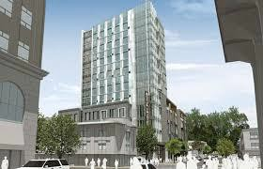
Another of the tall buildings, 2129 Shattuck Avenue is happily not a part of the height controversy. It’s a 16-story building that measures about 180 ft tall - total. It’s a hotel, a Marriott Residence Inn, with 334 guest rooms, a 14,500 sq. ft conference center and 2nd floor parking with 113 spaces, currently under construction at Center and Shattuck. Hotels are sought after revenue producers because of the
Transient Occupancy Tax (12%) that goes directly into City revenues. It was approved in 2016 without community opposition. However, in that same year it requested and received up to $13 million in deferred impact fees and in 2018, a waiver of Public Works/Transportation Fees of up to $4.25 million over 10 years. In 2020, because of multi-million dollar bond measures on the horizon, concerns about the fiscal impact of the Campus on the City, and increased demands on the City’s General Fund to provide more services to the University as well as fund such issues as improved fire safety and meeting the needs of low income people, we think a current financial update is in order.

The University: The City of Berkeley or The City of UC Berkeley
This sorry tale erupted in February 2005 when the City sued UC Berkeley over
concerns that the required California Environmental Quality Agreement (CEQA) documents did not adequately analyze a wide range of City impacts caused by University expansion (4,000 new students, 2,600 new housing beds, 2.2 million square ft of new buildings, 2000 new parking spaces, and the rising cost of services the City provides to the campus, etc.) The lawsuit was settled in May 2005 when then Mayor Bates signed a confidential agreement with the Berkeley Chancellor that cut the public out of any participation in developing the 2020 Long Range Development Plan (LRDP) between the City and the University. The Settlement Agreement included such matters as:

  - A new Downtown Area Plan (DAP) developed between UC and the City, with the City paying for a new planner, and if a plan wasn’t done by a certain date, the City would pay UC a $15,000/month fine.
  - Prohibit the City from collecting additional funds from the Campus for 15 years even if courts or legislation allowed any new payments.
  - The City would receive $1.2 million/year in additional payments for City services, with $400,000 of that amount at the discretion of the Campus.

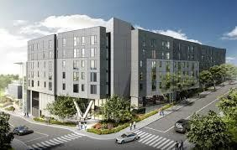
Community uproar eventually died down, and not much happened until early 2019 when the Campus proposed what they termed a “minor amendment” to the 2020 LRDP Environmental Impact Report. This “minor amendment” involved demolishing the existing garage on the corner of Hearst and Ridge, and constructing an up to 6-story mixed use building with 150 units of housing for faculty, visiting scholars and grad students and adding a 37,000 sq ft academic expansion to the existing site of the Goldman School of Public Policy.

Known as the Upper Hearst Project, it quickly became clear that it was far from being a “minor amendment,” because the Campus mixed into the proposed buildings an increase in the base student population on Campus of up to 11,300 new students. Of that number, approximately 9,000 have already been added in violation of the University’s numbers in the existing LRDP agreement. The Campus currently enrolls over 42,000 students so such an increase to a new base enrollment number would have significant
impact on students and the City by increasing the already huge pressure on the local housing market bringing higher rents throughout the City and accelerating gentrification and displacement of existing non-student households. With such an increase in overall City population provided by a tax-exempt institution, there would also be a significant impact on City services. The City’s analysis indicated that the net fiscal impact on the City of Berkeley increased from an estimated $11 million/per year in 2003 to $21 million for the year 2018 alone. There are a great many details in the Campus proposal and the City’s response that are too lengthy to include here so we urge readers to go to our website, Berkeley Neighborhoods Council, Click on the tab BNC E-News, Issue 25, May 2019 and also the City’s website to learn more.

Campus faculty jumped into the controversy early on by asking Chancellor Christ to withdraw the proposed project. She hasn’t done so. The project’s surrounding neighborhoods indicated they while they are opposed to the full extent of the proposal, they are willing to work with the Campus to craft a better proposal. The City indicated another lawsuit. The Regents approved the project in May 2019.

Currently a LRDP Community Advisory Committee (CAG) has been formed with 23 members representing the City and Campus. CAG members include 5 City reps from Council Districts 4, 6, 7, and 8 and the Mayor’ office, 5 business and non-profit reps, 4 from education. including BUSD, 4 arts and culture reps; and 4 UCB students and alumni reps. This project will be a “hot issue” throughout much of 2020, particularly around not only the cost of services

provided by the City to the Campus, but also how and where to house the large projected numbers of students since it is well documented that the Campus cannot house the number of students that are currently enrolled.

Loss of Local Land Use Controls: The State, University and BART all lined up
At the end of January, Scott Weiner’s bill, SB50, failed when it came up three votes short in a Senate Committee, thereby blocking it from going to the full Assembly for their consideration. As The San Francisco Chronicle put it, SB50 would have “all but eliminated single family residential zoning in the state by allowing for the conversion of vacant lots and homes into fourplexes” and also by reducing parking requirements and raising height limits around public transit (in Berkeley some have interpreted this to mean construction of apartment buildings on streets such as Spruce, Grizzly Peak, The Arlington, Hopkins, Claremont, etc.).
Those opposing SB50 say it will eliminate local control over zoning. They point out that “one size fits all” zoning does not take into account the differences in cities that are so important, such as high-risk fire zones, earthquake zones and other such situations that are unique to some cities, and that it actually will result in more gentrification and displacement of low-income home owners. Those in support of SB50 say that it’s a necessary fix to the State’s Housing Crisis. In support of SB50 are our representatives State Senator Nancy Skinner, Assembly Member Buffy Wicks, Governor Newsom, businesses and the construction industry. Senate President Pro Tem Toni Aikins (San Diego) vowed that the bill will come back this year and be approved by the Assembly.

It turns out that first-term Berkeley Council Member Rigel Robinson, District 7 (former student from the Sacramento area and newcomer to Berkeley) is also an ardent supporter of SB50. Recently, The Berkeley Daily Planet reported that Council Member Robinson posted the following on Twitter:
"The defeat of #SB50 is a victory for segregationists and climate denial. Tenant advocacy groups did not kill the bill, the homeowner lobby did. The solutions to our housing crisis lie in robust tenant protections and dramatic densification — yes, BOTH.”
(NOTE: We wanted to post a photo of Mr. Robinson, but it turns out that he is the only member of the City Council that does not post a picture of himself on the City’s website. So we highlighted his comments just so your eye will be drawn to them in the same way as they would be to a picture.)

Mr. Robinson is certainly entitled to his opinion, but now since he has lumped segregationists, climate deniers and homeowners together, possibly BNC should consider compiling a housing questionnaire and ask each Council Member to declare where they stand on some of these issues. That would be very interesting to know. We ask our readers, what do you think of that suggestion?
But the State and the University are not the only jurisdictions that want to control land use in our City. BART is on that same list with its plans for what will happen at the North and South Berkeley BART Stations. AB2923 (Chiu-San Francisco) approved in October 2018

requires the BART Board to adopt Transit Oriented Development (TOD) zoning standards that establish minimum zoning requirements for height, density, parking and floor area ratios for buildings on their properties. The City has two years, or until July 1, 2022, to adopt standards
that are in compliance with BART’s standards.

BART has designated the North Berkeley BART Station as an Urban/City Center which seems questionable given the fact that the Station is surrounded by a vast majority of single family homes. Three well attended meetings, outside of the future formal planning process to come, have been held about the North Station. At those meeting residents expressed support for housing, but which would be lower than the minimum seven to ten stories of height for new residential buildings that are anticipated to be in the BART requirements. Also, strong concerns were expressed about the possible elimination of existing parking used by commuters who live farther away than the Station’s neighborhoods.

BNC has not been able to find out BART’s designation for the South Berkeley BART Station, but its location is that of a more urban environment of surrounding commercial and residential uses. Many meetings have been held in association with the planning for the Adeline Corridor Plan which includes the BART Station. Again, residents have shown support for housing, but not at the density that has been suggested for buildings above seven stories. Strong concerns have been expressed by neighbors over retaining the existing Flea Market, designs that would be compatible with existing homes, and a significant amount of affordable housing as there has been considerable displacement of existing residents by new construction in that area.

The City and the BART Board have signed a Memorandum of Understanding to work together on the details regarding both Stations. A 15-member Community Advisory Group (CAG) is being formed, but members have not yet been announced. Further, the City has applied for a large grant to pay for the anticipated formal planning process to come. The CAG will submit a list of recommendations to the Planning Commission and the Planning Commission in turn will send recommendations to the Council. The City has also issued a Request for Proposals for consultants to staff the CAG and manage the community engagement process with a “project guidance document” expected by the end of February 2020.

This one is a sure bet to take hours of very important citizen participation during the coming year. We all need to be aware and take the time to be involved whether or not you live near either Station because of the high level of importance of the BART system. Your representative on the BART Board is Rebecca Saltzman and the Council Member for the North Station is Rashi Kesarwani 510-981-7110). For the South Station is Ben Bartlett (510-981-7130

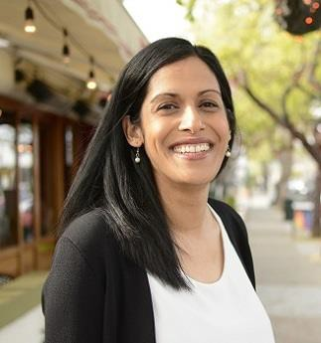

The Adeline Corridor Plan: A new hotel, housing and commercial proposal
After many months, the Adeline Corridor Plan is coming up for final approval and at least one new development proposal is challenging the Plan. BayRock Multifamily,LLC,
based in Oakland, has written the City complaining that the draft plan will downzone the current Walgreens site at 2801 Adeline, located across the street from Berkeley Bowl. (See the BayRock letter June 4, 2019 on the Berkeley Neighborhoods Council website, click on “Documents,” then on “Archived Documents.”) They are considering constructing a new seven- story hotel with 215 guest rooms, 84 market rate residential units and 32,000 sq ft of commercial uses over underground parking on that site. They argue that the site is not surrounded by residential uses, is in the midst of a well-traveled area that is near to public transportation (BART), in the heart of a Priority Development Area (Opportunity Zone) and across the street from the “largest, revenue-generating grocery market in the entire City.” No image of this new project has yet been submitted to the City or the neighbors for comment.

At a preliminary meeting this proposal was mentioned and attendees report that supporters of this proposal made what sounded like the developer would file a lawsuit if changes in the Draft Corridor Plan weren’t made. BNC has since learned that City Staff is now proposing to change the original sub-area boundaries to include the Walgreens parcel and other nearby parcels in the higher density South Shattuck subarea after receiving a letter from Bay Rock MultiFamily, LLC. We haven’t seen this change but it’s implied that it would up-zone that part of South Shattuck which includes the Bowl and Walgreen's.

Readers will remember that BNC held a Forum on Opportunity Zones (OZs) in September 2019.

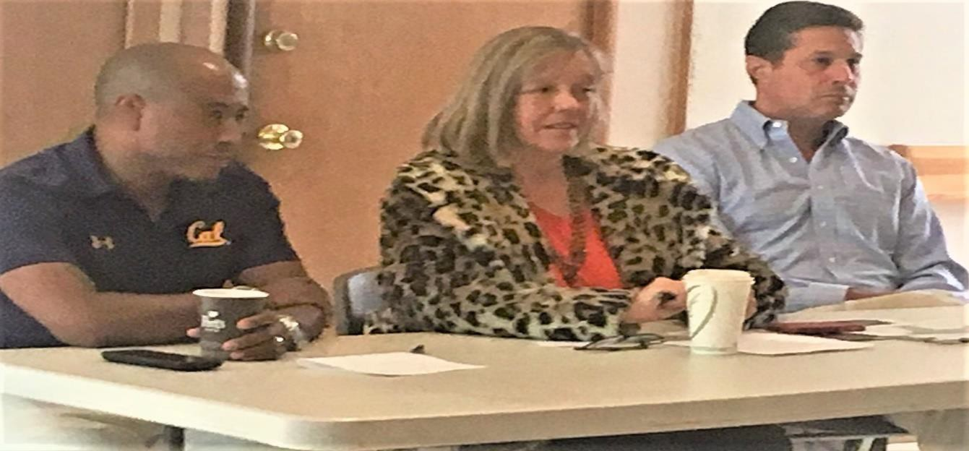
In attendance at that Forum are, left to right, Council Member Ben Bartlett (District 3), Council Member Kate Harrison (District 4) and Christopher Karachale, who was referred to us by Jordan Klein, Berkeley’s Economic Development Manager. Mr. Karachale is a Berkeley resident who is an experienced tax advisor on State, Federal and International issues. He has recently asked BNC to remove his power point presentation from our website due to changes that have occurred. BNC has agreed to do so, but we also want to know what those changes are and assess what affects they might have on our City. That request is pending.
We do know from what was said at a recent Adeline Corridor Subcommittee meeting that the impact from OZs in Berkeley is likely to be less than had been predicted. The reason given was that the State of California did not agree to provide the same tax benefits as those given by the Federal tax office. Hence, investors in California would not get as high a return on their investment as if they had invested in a state where OZ investors would receive both state and federal exemption from capital gains taxes.
` We understand that City Staff have come up with a list of opportunity sites for development in the Adeline Corridor that includes the Berkeley Bowl, Walgreens, and the South Berkeley post office among other sites. Exactly what all of this means is not yet clear, but as we are writing this, a controversy is forming over the amount of development around and within the South Berkeley Station. We’ll have to report to you more about this in our next issue so stay tuned.

Shadowing of Existing Properties by New Development: Who owns the sunshine?
It comes up all the time in regard to proposed development -- how much shadowing by new development is allowable in the windows and backyards of existing properties that have or don’t have solar panels. So far here is no real answer. A City subcommittee is working on establishing objective standards, but it’s unclear the direction those discussions around sunshine access will take. It’s a problem that affects both residential and commercial properties. It’s an issue in regard to the Adeline Corridor Plan as it applies to residential property and where people are being urged to make their opinions known to the Council and the Adeline Corridor
Subcommittee. It’s also a factor in a current proposal being considered for a project on Telegraph Avenue that we thought we might comment on as an example.

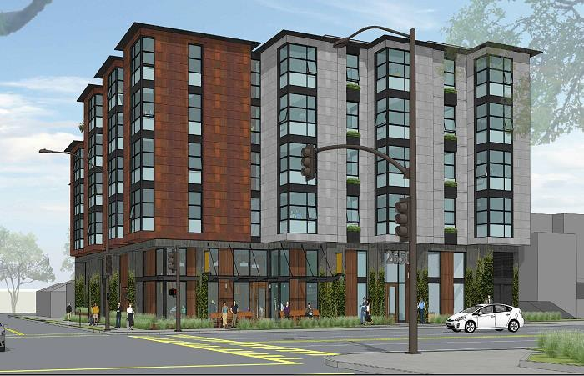
The 2650 Telegraph Ave proposal is a five-story mixed use building with 45 dwelling units, presently the site of a former restaurant,
Bacheeso”s. The building will be 59.6 ft high (60 ft is allowed), and it has a Density Bonus. Thirty six parking spaces are required, but the project is asking for 20 because it’s on a transit corridor.

Berkeley Orthodontics is located next door to the proposed new building and has raised objections because their solar panels will be blocked by the new building’s height. They state their practice involves people of all ages up to elderly adults,
But they also say they serve children with special needs who are sensitive to noise and vibration and when they are in the building, special measures are taken to meet their needs. They also have concerns about patient parking since the new building will have so few spaces that serve the
building’s residents.

In January 2018, the Council set up a Joint Subcommittee to address issues such as sunlight access. Known as the Joint Subcommittee for Implementation of State Housing Laws (JSISHL), it has representatives from the Zoning Adjustments Board, Housing Advisory Commission and Planning Commission. They meet on the 4th Wednesday of each month in the evening, but check the community calendar before attending. They are supposed to finish their work by March 2020. They have stated they want to include objective sunlight access standards, but they have been moving very slowly, and their work will also have to be approved by the Planning Commission before going to the Council.

And More to Come………………………
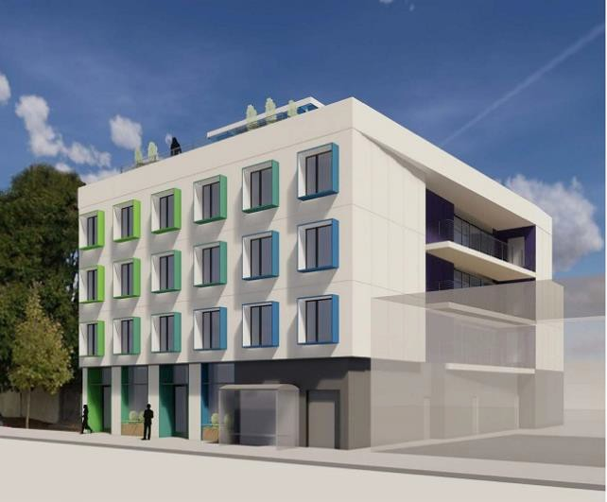

Shadowing is also one of the concerns regarding the controversial project proposed at 2435 San Pablo Avenue on the east side of San Pablo about 100 yards north of Dwight Way. The project is a mixed-use building with 42 units, 800 sq ft of retail/commercial space and parking for 50 bikes. The developer did a survey of on-street parking spaces and reported a 19% availability, so City staff didn’t find that the lack on on-site parking would be a problem since the proposed building was located on “transit-rich” San Pablo Ave. In the discussion about parking, we didn’t find any references to AC Transit’s proposed Rapid Bus system which is

currently under discussion. AC’s proposal will remove at least some parking along San Pablo. Shadowing will occur on the eastern side of the project on properties located on Byron.

However, the neighbors’ biggest objection to the project was that it was designated a non-transient residential hotel. The proposed 42 units are designed for “co-living” which is

“consistent with non-transient residential hotels.” This means that each unit has a central kitchen which is surrounded by several bedrooms, each with their own bathroom. The developer stated that his intent is to rent out each bedroom to one person, but he also says that more than one person will likely want to live together, so he calculates 1.2 persons per bedroom so he predicts the population of the building will be about 50. The City has classified the units as Group Living Accommodations (GLA), but nothing is in place to prevent more than 1.2 person per bedroom. Open space per person requirements listed in housing codes are supposed to be met in this project by providing one balcony for each unit and a shared roof top. The roof top will also have a laundry used by all residents. Compliance with housing code regulations are difficult to determine when the total population is uncertain. ZAB has required the developer to come back with a detailed operating plan showing how the developer intended to run the operation. So far, no information has been posted on what discussions are taking place nor how they will be reviewed.

Co-housing seems to be the coming attraction in applications from developers, so this issue is bound to jump out at us in the coming year. However, this E-News is already too long, so we will be reporting on that more extensively in our next issue.

In the meantime, we suggest that readers attend our regular meetings that are always held on a Saturday from 10am to noon at the Tarea Hall Pittman South Berkeley Branch Library, 1901 Russell Street. The next meeting will be held on February 8, following that on March 14, 2020. Attending these meetings is the very best way to become informed about what is happening in Berkeley. Each agenda will list dates for upcoming meetings and for Forums that we organize around specific topics. All are welcome to attend.

