Connect with CP&DR
Follow us on Facebook and Twitter

Articles by Category

Reports
Insight
Legal Digest
News Briefs
Blogs
Podcasts
Job Announcements
Single Purchase Store

You Are Here: Home » Articles » How Berkeley Will Move Away From Single-Family Zoning

How Berkeley Will Move Away From Single-Family Zoning
Josh Stephens on
Mar 2, 2021
Berkeley, Housing, RHNA, Single-Family Zoning
Previous | Next
In 1917, the Supreme Court ruled in Buchanan vs. Warley, that cities could not impose race-based residential segregation. Two years later, the City of Berkeley became one of the first municipalities to try an innovation: zoning that excluded anything but single-family residences.
Last week, the Berkeley City Council voted unanimously, 5-0, to reverse a 101-year-old policy that detractors say had been allowed to stain the city for far too long. The message of social justice resonated with stakeholders and council members alike.
Berkeley is the second city in as many months to commit to challenge the sanctity of single-family neighborhoods and allow residences of up to four units via conversion or new construction. The Sacramento City Council voted unanimously in January to move in the same direction and several other cities are considering similar moves.
The department will draft zoning regulations in conjunction with its update of the city's housing element. The housing element update is, in turn, motivated by the city's forthcoming Regional Housing Needs Allocation, expected to be around 9,000 units for the upcoming eight-year cycle. Jordan Klein, the city's interim planning director, said he is hopeful that a signification portion of the expected RHNA can be accommodated by upzoning of single-family lots. Without it, in fact, the city would be limited to only a handful of commercial corridors and existing multifamily neighborhoods.
"We can't just rely on our commercial districts and our avenues," said Klein. "We can't just rely on our downtown to accommodate these new units."
In explaining Berkeley's recent move – after decades of slow-growth policies – Klein credited a recent report from the UC Berkeley Othering and Belonging Institute that essentially contended that racial segregation persists in the Bay Area and correlates strongly with single-unit zoning.
"As planners it's so critical that we understand the history of our profession," said Klein. "So often planning and development policies have been used as a means of furthering racial inequities and even white supremacy."
While many members of Berkeley's famously progressive citizenry are likely celebrating the move, the arduous work of implementing it now falls to the city's planning department.
Though the upzoning policy is clearly considered by many stakeholders to be a moral victory, the pragmatic victory will depend on whether multi-unit buildings actually get built. Klein said the city is very early in the process but said the city does want units to actually get built.
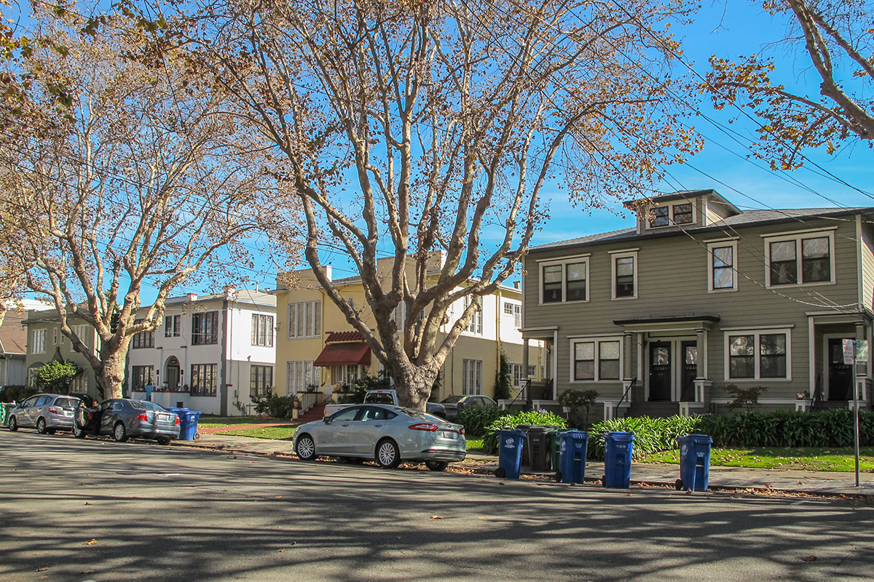
Fourplexes sit peacefully on a Berkeley street. Image © Opticos

"We are looking at constraints, objectives for housing production, conducting a site inventory, and putting together a set of zoning amendments that will enable us to boost production," said Klein.
The city will determine standards such as massing and setbacks, presumably with an eye toward preventing the development of overwhelmingly large multiunit buildings where single-unit homes once stood. Loni Gray, a Berkeley-based consultant who advises homeowners on construction of accessory dwelling units, said that it's equally important for the city to get its design standards right. Stakeholder buy-in will likely depend on design standards that compel new and updated buildings to blend in with prevailing styles.
"We can do it beautifully and well so it doesn't abruptly change the character of our streets," said Gray.
She suggested that a design review board, albeit one with limited powers, could help ensure that an upzoned Berkeley does not lose its historical and architectural character.
"I think there has to be a design review. I think probably design review lite," said Gray. "At the same time, I think it has to be a by-right, ministerial type of approval. Does it meet and match the character of the neighborhood it's going into?"
Some regulations will also have to be deconstructed. In some of the city's zones, the number of allowable units depends on a lot's square footage. Klein said that his office is cataloging those zoning regulations and will likely have to rewrite them if they conflict with the new upzoning policy.
"In order to accommodate more units per lot, we're going to have to go back and take a look at it. Either eliminate it as a standard, or modify them district by district," said Klein.
As well, the city may need to make accommodations for areas the face high fire danger.
"A lot of our lowest-density residential districts are in the hills, in declared fire zones," said Klein. "Looking at our infrastructure for fire suppression and our roads and capacity for routes of egress and considering what other constraints those might put on housing capacity."
Gray said she hopes the process to take place gradually so as not to shock existing residents.
"We've got to let it start and find its pacing," said Gray. "For embracing the change, I think we need to be more gentle in the launch."
She suggested that the city should ensure that incumbent homeowners convert their own properties and expressed concerns about large-scale developers. She proposed regulations that might prevent corporate development, including rules to limit permits to owners who intend to occupy their redeveloped properties and/or to owners who do not own multiple.
Ben Metcalf, managing director of the Terner Center at UC Berkeley and former director of the state Department of Housing and Community Development, said that, contrary to the policy's social justice goals, it's possible for speculators to try to scoop up homes and redevelop them to the greatest possible extent. On the other hand, the housing market, especially in Berkeley, does not necessarily lend itself to high turnover.
"They're not, strictly speaking, just commodities," said Metcalf. "People happily live in their homes. Poeple make a lot of non-economic decisions that lead to stickiness."
In a worst-case scenario, the policy could create localized chaos in the housing market that could disadvantage and even displace unsophisticated, low-income homeowners.
"One could imagine speculative investors acquiring homes from individuals at prices that are below true market value taking advantage of this regulatory change," said Metcalf.
The solution, he said, is outreach and education. "You'd want to make sure that residents in West Berkeley and South Berkeley.... including many elderly homeowners, including many people of color recognize what this change means for them," said Metcalf.
The best way for the city to encourage homeowners to convert their single-family homes might be to spare them from the often onerous, inscrutable permitting process. Gray suggested that the planning department should establish a counter that specializes in permitting ADUs and single-family home redevelopments.
"If we are indeed putting the power into the hands of citizens, then let's not punish them with a protracted, difficult process," said Gray. "A dedicated staff with consistency is going to go a long way."
Klein noted that, whatever assistance homeowners might need to build ADUs, they will likely need much more for conversion to duplexes, triplexes, and fourplexes. He said that he is aware of developer buying multiple homes in Berkeley in part to put ADUs on them.
"We've also seen property owners who are going about it themselves," said Klein. "I think building a fourplex is definitely different than building an ADU."
Longstanding homeowners might go to the trouble of building a multiplex in part so that they can downsize and monetize their propertie, without having to move out of a home that has become too big for them.
However they are built, demand for new multiplex units, in addition to ADUs, is likely to be brisk in Berkeley, perhaps more so than in other parts of the Bay Area, because of its student population. Klein said that undergraduates and grad students alike drive demand for smaller units.
"Our market acts a little bit differently than the regional market," said Klein. "The student market really drives our housing market. Related to that is the strong demand for small units."
Perhaps of greatest concern, though, is the low-income market. Metcalf suggested that the city view the policy not just as a zoning change but also as a financial program. Some funds the city traditionally dedicates to traditional multifamily housing could be spent on multiplex conversions. Moreover, the city's housing authority could arrange for ADUs and added multiplex units to serve residents who receive rental assistance.
"This could open up neighborhoods to Section 8 voucher holders who are able to access what would be naturally affordable, by-design smaller homes," said Metcalf. "All of those opportunities emerge, which are, I think, in some ways more powerful in terms of creating truly mixed income, inclusive communities"
Contacts & Resources
Loni Gray, ADU Advisor, Project Catalyst, lonigray@sonic.net
Jordan Klein, Interim Director, Department of Planning & Development, City of Berkeley, jklein@cityofberkeley.info
Ben Metcalf, Managing Director, Terner Center for Housing Onnivation, UC Berkeley, ben.metcalf@berkeley.edu

